NORFOLK COUNTY COUNCIL proposes to make a Temporary Traffic Order affecting the C285 Lower Street/Slad Lane from its junction with U57144 Upper Street for 380m eastwards in the PARISHES OF SALHOUSE & WOODBASTWICK because of BT pole replacement works.

The road will be temporarily closed (except for access) on 10th December 2021 for the duration of the works expected to be about 1 day within the period.

Alternative route is via: Slad Lane, Southfield Lane, B1140 Low Road/Norwich Road/Mill Road, Lower Street (Salhouse, Woodbastwick).

(If necessary the restriction could run for a maximum period of 18 months from the date of the Order).

Penalty: £1000 maximum fine on conviction and/or endorsement for contravention.

In the event of the start date being delayed the new start date will be displayed on site in advance.

The person dealing with enquiries at Norfolk County Council is Vinnie Purdy (Community and Environmental Services) Telephone 0344 800 8020.

Dated this 19th day of November 2021

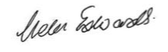

Helen Edwards
Chief Legal Officer

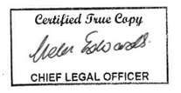

County Hall
Martineau Lane
Norwich
NR1 2DH

