Remember – In an emergency call 999 and never put yourself or anyone else in danger.

Main Contact - Plan Co-ordinator & Deputy
Co-ordinator | Address | Telephone | Email
Kit Cator  Parish Council Chairman | ‘Copperhole’  Horning Road  Woodbastwick  NR13 6HJ | 01603 720276 | kit.cator@gmail.com
Deputy | ‘Wayside’  Union Road  Smallburgh  NR12 9NJ | 01692 536056 | woodbastwickpc@gmail.com
Caroline Purdy  Parish Council Clerk | ‘Wayside’  Union Road  Smallburgh  NR12 9NJ | 01692 536056 | woodbastwickpc@gmail.com

Volunteers
Name | Address | Telephone | Email
Kit Cator | ‘Copperhole’  Horning Road  Woodbastwick  NR13 6HJ | 01603 720276 | kit.cator@gmail.com
Vivienne Adshead  Parish Councillor | Honeysuckle Cottage  125 South Walsham Road  Panxworth  NR13 6JG | 07967 626644 | vivyy@hotmail.co.uk
Mark Hadden  Parish Councillor | Thatched Cottage  School Hill  Ranworth  NR13 6JB | 01603 270325 | mark.hadden1@btinternet.com
Lara Cole  Parish Councillor | The Old Vicarage  Woodbastwick  NR13 6HH | 07915 914180 | laracole@scoultonlegalservices.com
Stuart Goodhall  Parish Councillor | Sotshole  Ranworth  NR13 6HU | 01603 270952 | goodallhilltop@aol.com
Alby Cator  Parish Councillor | Woodbastwick Estate Office  Southfield Road  Woodbastwick  Norfolk  NR13 6AL | 01603 722133 (office hours) | actor@dircon.co.uk
Andrew Lee  Parish Councillor | Hall Farm  Panxworth  NR13 6JQ | 07770 546090 | andrew@panxhall.co.uk
xxxxx  Licensee | The Maltsters PH  The Hill  Ranworth  NR13 6AB | 01603 270900
Jon Bingham  Manager | Woodfordes / Fur & Feather Inn  Slad Lane  Woodbastwick  NR13 6SW | 01603 720353 ext. 2088  07836  752181 | jon.bingham@woodfordes.com
Helen Thurtle  Churchwarden | St Helen’s Church  Woodbastwick Road  Ranworth | 01603  720686

Key Locations – This should include somewhere to meet and co-ordinate your actions from as well as keeping people safe and warm for a short time during an emergency.

Name | Address | Telephone | Other Info
Woodbastwick Village Hall | Slad Lane  Woodbastwick  NR13 6HL | Norma Jablonowski  01603270570  Kit Cator  01603 720276
Ranworth Village Hall | Broad Road  Ranworth  Norfolk  NR13 6HS | Maggie Manton  01603 270803  Ian Colman  01603 270366 | ranworthvhc@gmail.com
Pubs | The Maltsters PH  The Hill  Ranworth  NR13 6AB  Fur & Feather Inn  Slad Lane  Woodbastwick  NR13 6SW | 01603 270900  01603 720003
Post Office, Shop & Cafe | Post Office  Farm Lane  Ranworth  NR13 6HY  Granary Stores  Ranworth Staithe  Farm Lane  Ranworth  NR13 6HY  St Helen’s Church  Visitor Centre & Café  Woodbastwick Road  Ranworth  NR13 6HT | 03456 112970  01603 270432
Churches | St Helen’s  Woodbastwick Road  Ranworth  NR13 6HT  St Fabian & St Sebastian  Horning Road  Woodbastwick  NR13 6HH

Community Risks - Think about the things which could affect your community
 | Very Likely | Likely | Less Likely | Negligible
Flooding  Coastal, River, Surface | ☐ | ☒ | ☐ | ☐
Severe Weather  Storms & Gales | ☐ | ☒ | ☐ | ☐
Utility Failure  Loss of water, electricity Gas, telephones | ☒ | ☐ | ☐ | ☐
Transport Issues  Main routes in or out blocked | ☐ | ☐ | ☒ | ☐
Human Health  Pandemic Flu | ☐ | ☐ | ☐ | ☒
Fire | ☐ | ☐ | ☒ | ☐

Plan Triggers – in the event of the Plan Co-Ordinator or Deputy receiving the following, this plan will be actioned.
- Environment Agency Flood Warning
- Met Office Severe Weather Warning
- Call from Police
- Call from Local Authority
- Calls or messages from local residents

Plan Actions
- Call round volunteers and organise meeting or give telephone briefing
- Meet at pre-arranged location and discuss actions
- Carry out actions (e.g., check on vulnerable neighbours)
- Report back to plan co-ordinator
- Liaise with Local Authority Emergency Planner if assistance required (i.e., help from voluntary sector such as 4x4 Response)
Advice and Preparation

As shown in the risk index, we are most likely to encounter bad weather, loss of utilities and mild-moderate flooding.

We do not wish to panic residents, but as part of the Norfolk Flood Alliance and the Norfolk Resilience Forum we are preparing this document to give you practical help and guidance on what to do in the event of an emergency.

Flooding

Check if you’re eligible to sign up for flood warnings
Be sure you’re aware of any forthcoming floods by signing up for free online via www.gov.uk to check if you can receive warnings or call Floodline on 0345 988 1188 or textphone: 0345 602 6340.
Floodline is a 24-hour service for flood warning information and general advice.

Move treasured possessions to a safe place
Photo albums and personal mementoes that can’t be replaced should be moved somewhere safe or upstairs. Don’t wait until a flood is happening to move them as it may be too late or too dangerous.

Write up a personal flood plan
- Use this plan to help you decide on your own course of actions, where you will go to safety and who you will contact, for example. A personal plan template can be downloaded from our parish website to help you get started.
- Check with your council if pets are allowed at evacuation centres - most allow them, but it’s best to be sure. Pets will be allowed at your local key venues (churches, pubs, village halls).
- Know where to get hold of sandbags – Broadland District Council do not normally provide these. However, if a flooding emergency has been declared they will try to distribute sandbags to affected locations but supplies are limited and their advice is to buy your own from builder’s merchants or DIY stores. For maximum effectiveness sandbags are best used in addition to other flood protection devices such as a door flood barrier. It is your responsibility as a property owner or occupier to buy and install flood protection products.
- Make a list of what you’d need to move in the event of a flood (things like your car, furniture and so on) and where you’d move them to.
- Know in advance how and where you can shut off your electric, water and gas supply.
- Visit the Environment Agency website and local weather forecasts to check on the 5-day flood warnings and any severe weather warnings in place.

Prepare a ‘flood kit’ in the event of evacuation
This should be kept in a safe place and can include things like:
- This plan! Plus, contact numbers for your local authority emergency helpline, home insurance company 24-hour number and policy number, neighbours, local police station, gas, electricity and water supplier numbers.
- Warm, waterproof clothing and blankets, water, food, essential medication, gloves, wellingtons, a torch, baby food and baby care items, pet food and pet carriers. Keep a “grab bag” stocked and ready to go.

If a flood is expected in your area:
- Move furniture and electrical equipment, plus sentimental items and important documents to safety indoors. Move your car away from risk, if possible.
- Take up rugs and carpets if you can. Remove curtains or drape them high up over their rods.
- Turn off electricity, gas and water supplies.
- Put sandbags in place and fix flood boards to doors.
- Tune into local radio for news and updates.

How to reduce the impact of floods
If your home is at risk of flooding there’s lots you can put in place to help protect it and make it more resilient to damage.
Extra flood protection equipment that can help includes:

Flood boards - These can be fixed to your doors and windows when a flood warning is in place.

Plastic covers for air bricks - These will seal air bricks to prevent water from entering your property.
Making a few home improvements could mean less damage and an easier, and cheaper, clean-up too:
- Lay ceramic tiles instead of carpets on floors.
- Move electrical sockets to at least 1.5 metres up the wall.
- Fit non-return valves to drains and water inlet pipes.
- Fit a boiler upstairs or high above ground level.
More information on flood damage prevention can be found online at www.befloodready.uk

During a flood
In the event of a severe flood warning, there can be danger to life so you’ll need to be prepared to act swiftly and calmly.
- Keep yourself and your family safe. Your first priority should be safety. Get to a safe place with a means of escape, away from flood water. Be ready to leave your home. Follow the advice of the emergency services.
- Stay within or leave your home if you're told so. If evacuated, you will be taken to an evacuation centre run by your local council or to one of the local venues listed here.
- If in imminent danger, call 999 for the emergency services.

What to do after a flood
When you’re sure it’s safe to return to your home, take care when entering as there may be hidden dangers in floodwater such as sharp objects and sewage pollution.
If your electrical supply hasn’t been switched off at the mains, do not on any account touch sources of electricity when standing in flood water. Get a qualified electrician to come to the property to switch off the power.
Everyone will react differently to an event like a flood, you may feel shock, helplessness, frustration and anxiety or

- Isolation and loneliness
- Disbelief
- Have difficulty sleeping
- Suffer Flashbacks and Nightmares
- Experience low mood and depression
- Anger.
These reactions are normal. There is no right or wrong way to cope or be feeling.

Ways of coping and helping yourself

- Rest and be with those who are important to you and take time to reflect on what has happened.
- Don’t bottle feelings up, talk to family and friends about how you feel.
- Keep a routine. Although this isn’t always possible, trying to keep to your regular daily activities can help stay busy and channel your emotions.
- You can make a list or plan the next few weeks. This can help calm down anxious feelings of getting back to normal.
- Encourage children to express their feelings, drawing and games can be good way for children to express themselves.
- Don’t take on too much or make any major life changes
- Avoid excessive alcohol and drugs. They are often used as a way of coping but they tend to block the feelings that will emerge in the end.
- You know yourself and the people you love best, so are best placed to decide what works for you.

For more information on managing after a flood, please visit our parish website and download the “Understanding and Coping with the Emotional Impact of a Flood” leaflet.

Cleaning up after a flood
In many cases, your insurance company can pay for professional help to clean up your property.
The clean-up will usually involve:
- Pumping out water from your home using a generator
- Cleaning and disinfecting the property. Avoid using high pressure hoses as they can blast contaminated particles into the air.
- Drying out the property with dehumidifiers.
- Local councils can supply skips and advise you on disposal of sandbags as they may need to be treated as contaminated waste.

Home insurance and flooding
According to the Chartered Insurance Institute, the average household flood claim amounts to £50,000. Check how much your policy covers you for flooding, if the policy replaces your items new for old, and if it has a limit on repairs.

Making a claim
You should inform your insurer about flooding as soon as possible.
They’ll let you know whether you should clean the property or if they will send professionals to do that for you.
Many policies also cover the cost of temporary accommodation where you can stay while clean-up and repairs are underway. This could be in a B&B or rented property.
Your insurance provider will send a loss adjuster to your property to inspect the damage and to confirm what repairs and replacements will be covered by your policy.
Keep a record of flood damage for future reference.
- Mark the height of flood waters on the walls in every room affected.
- Photograph or video all damage to your home and contents.
- List all parts of the property and contents damaged and, if your policy covers it, all food spoilt too.
Even if you live in an area at risk of flood or have made a flood claim in the past, it should still be possible to get reasonably priced insurance thanks to the “Flood Re” scheme. Under the scheme, your insurer pays out if you make a valid claim for flood damage, but it can then claim back a proportion of the money from the Flood Re fund. This reduces the insurer’s financial risk, so it can offer you cheaper cover.

Loss of Utilities
Utility outages can be very disruptive to our everyday lives, with so much of our day-to-day activities reliant on a reliable supply of power, gas, water, sewerage and telecommunications. The services that keep our modern society functioning can quickly begin to unravel when the supply of any of these essential utilities is reduced or impeded.
For this reason, the four main utility network suppliers that operate in your area are recognised as Category 2 responders under the Civil Contingencies Act and are represented on the Local Resilience Forum.
Keep a record of your suppliers, agreement numbers and use the contacts list below to help. Make a note of any calls made, the times and dates in case it is needed.
Severe Weather
- Register for weather warnings, keep watching and listening to local news and weather or set up Google alerts and location data on your mobile for up-to-date forecasts and warnings.

Cold weather, ice and snow can cause serious difficulties and health problems. One of the best ways to keep well during winter is to keep warm, but with the cost of heating our homes rising, there are tips on our parish website and a few below to help.

You may be able to claim financial help with heating your home:

Norfolk Warm Homes: https://norfolkwarmhomes.org.uk/
Norfolk Assistance Scheme: https://www.norfolk.gov.uk/care-support-and-health/support-for-living-independently/money-and-benefits/norfolk-assistance-scheme/financial-help
Cold weather payments: https://www.gov.uk/cold-weather-payment

Preparing Your Home

- Heat your main living room to around 18 – 21 Celsius, and the rest of your house 16 Celsius
- Make sure radiators or portable heaters are not obstructed by furniture or furnishings
- Keep curtains drawn and doors closed to block out draughts and insulate hot water tanks
- Water pipes and taps may freeze if they are exposed to freezing temperatures. If pipes freeze or burst turn off your inside stop tap immediately. Make sure exposed pipes and taps are properly insulated.
- Think about what may be impacted by strong winds; in windy weather innocent items can become dangerous. Secure garden furniture, wheelie bins, prune trees and bushes and check your roof for loose tiles.
- Many of us spend more time at home during Winter, especially during the Christmas & New Year periods. Buying cheap online electrical goods, or perhaps Christmas tree lights, may mean that the products don’t meet fire safety standards. Remember to test your smoke alarm regularly – Test it Tuesday is a good motto to live by!

Prepare Yourself and Your Family

- Get a flu vaccine – flu will often get better on its own, but can make some people seriously ill, please consider getting the flu/Coronavirus vaccines if you’re advised to.
- Keep active – try to reduce the amount of time you spend sitting down during the day, break up time spent being inactive by walking around.
- We all feel down from time to time, no matter our age. If you’ve not been feeling yourself, contact the NHS mental health helpline for 24-hour advice and support: nhs.uk/urgentmentalhealth or call the Samaritans on 116 123.
- Keep washing your hands regularly, with soap and water for around 20 seconds.
- Make sure you collect prescriptions before pharmacies shut for Bank Holidays.
- Have regular hot drinks and at least one hot meal a day.
- Wear warm clothing, plenty of thin layers are better than one thick layer.

Coping with a Heatwave

- Try to stay cool and hydrated
- Stay indoors between 11am – 3pm, close curtains in rooms that face the sun, open windows for ventilation
- Avoid excess alcohol
- Apply sunscreen, wear a hat and use shaded areas to rest
- wearing loose, cool clothing, and a hat and sunglasses if you go outdoors
- have cool baths or showers, and splash yourself with cool water
Useful Contacts
Service / Role | Additional info | Telephone | Website / email
Emergency Planning  Broadland |  | 01603 430434  01603 705121 (out of hours) | emergency-planning@broadland.gov.uk
Broadland District Council | Help Hub for advice and resources | 01603 430431 | helphub@southnorfolkandbroadland.gov.uk
Water - Anglian Water | 24hr Control | 03457 145 145 | www.anglianwater.co.uk
Electricity - UK Power Networks | Supply interruption. 24hr fault line  Substation issues. (Vandalism or unauthorized entry)  Powerline damage | 105 | www.ukpowernetworks.co.uk
Gas – CADENT formerly National Grid | 24hr emergency number for gas safety | 0800 111 999 | www.nationalgrid.com/uk
Telephones  loss of service | Individuals will need to contact their own service provider.
Telephones  Damage to Infrastructure | BT Openreach  Damage to phone lines, poles, street cabinets, man-hole covers etc | 0800 023 2023 (option 1)
Health - NHS Choices | 24hr health advice and information | 111 | www.nhs.uk
Local Police | Hoveton Police Station  14 Stalham Road Hoveton NR12 8DG  Sprowston Police Station  105-109 Wroxham Rd Norwich NR12 9RY | 101 / 999
British Red Cross | Support at Home Service for those aged 60+ | 01603 288320  07834 005850
Always call 999 if it’s an emergency.
Map
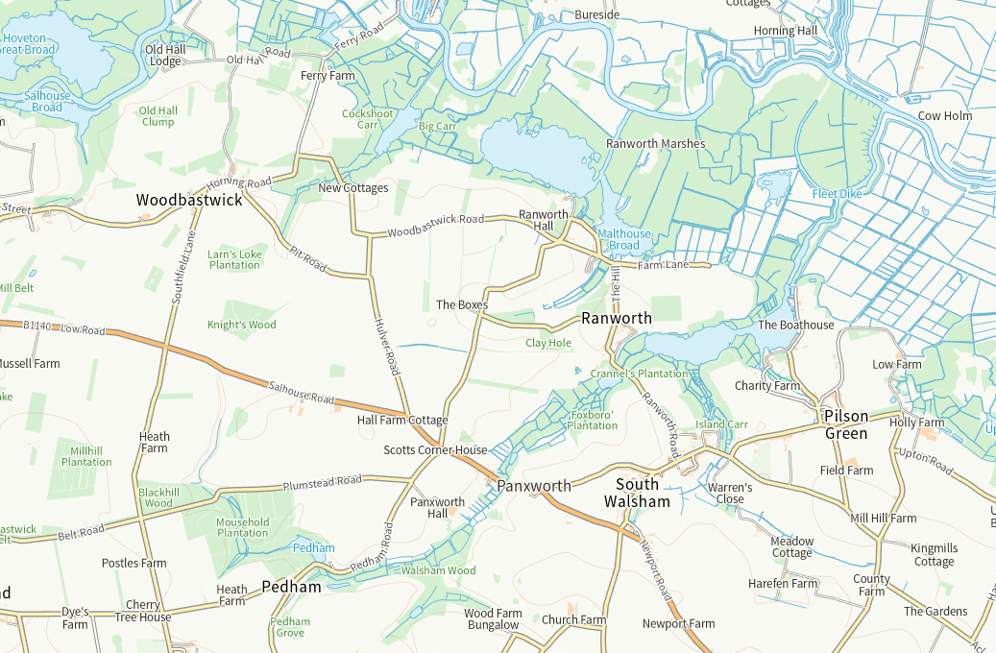

Community Emergency Plan

Woodbastwick, Ranworth & Panxworth

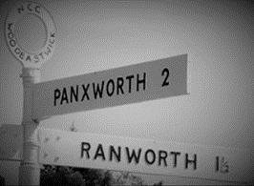

This document and further links and advice are available via our website
Woodbastwick Parish Council incorporating Ranworth and Panxworth

