Woodbastwick Parish Council Inc. Ranworth and Panxworth

Minutes from the Parish Council Meeting of 10th June 2026 at 7.30pm held at
Ranworth Village Hall
Present: Vivienne Adshead VA Chair
Lara Cole LC Vice-Chair
Andrew Lee AL Councillor
Mark Hadden MH Councillor
Stuart Goodall SG Councillor
Alby Cator AC Councillor
Mark Bowen MB Councillor
Caroline Purdy CP Clerk
Public: Cllr Paul Newstead PN Broadland District Councillor
Cllr Ed Matthews EM Broadland District Councillor (Wroxham Ward)
Apologies: None
Item | Action
Public & District Council Reports
Cllr Matthews was welcomed and introduced himself as the new Reform Councillor for Wroxham Ward and read excerpts from his full report below:
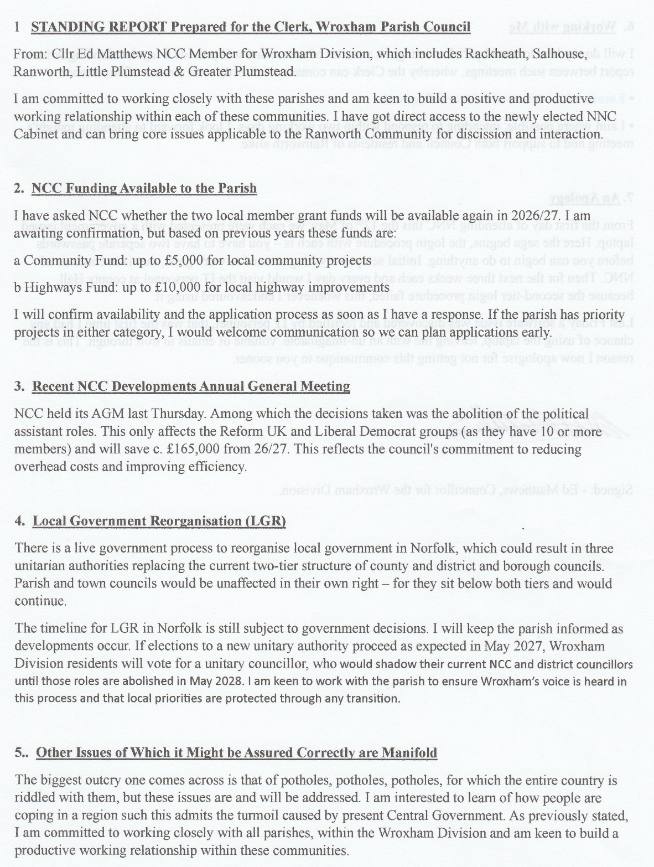
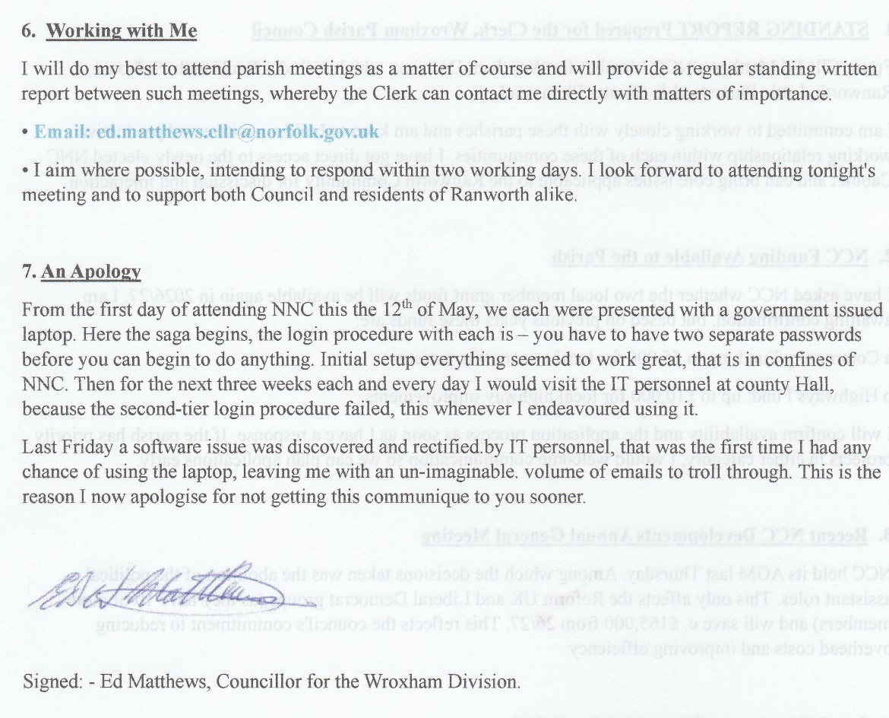

Cllr Newstead reported that the Greater Norwich Local Plan had been finalised. The need for housing was identified and had increased to 2,590 new homes annually and there is currently a call for land to build upon.
Broadland (BDC) and South Norfolk District Council’s Business Builder has restarted with the aim of supporting businesses to grow and in turn help the growth of the local community. Enquiries can be directed to the Economic Development Department via business@southnorfolkandbroadland.gov.uk or 01603 980441.
The Renters’ Rights Act 2025 is now in force; more information can be found via the BDC website.
1 Apologies – as above.
2 Declarations of Interest
AL declared a pecuniary interest in agenda item 7(a) and was granted dispensation.
SG declared a pecuniary interest in agenda item 5(a); no dispensation was given.
3 Minutes of the Last Meeting
The minutes from the Parish Council Meeting from 7th May 2026 were agreed and signed.
4 Matters Arising
None.
5 Planning & Enforcement  - Application BA/2026/0129/HouseH – installation of solar panels onto an existing extension at Sotshole, School Hill, Ranworth. Associated documents were circulated to councillors ahead of the meeting; the proposal was supported. | CP
6 Highways  - Traffic Issues following Panxworth Road Closure – Councillors outlined the issues surrounding this item to Cllr Matthews who asked the clerk to send him a full update to enable him to raise this with Highways.  - VA had received a resident’s complaint regarding overgrown hedges at Norton Hill; South Walsham Parish Council Chair had raised this with Highways, who believed that this was with their contractor to complete. However, it seems this has been missed, most probably due to being the landowner’s responsibility. SG confirmed the landowners and the clerk will liaise with Highways again.  AL reported that the end of Panxworth Hall drive, on Pedham Road, was once again flooded. Clerk to report and advise Cllr Matthews of the historic issues and actions here so he can investigate. The clerk requested photos to support another report to Highways.  LC reported a resident’s concerns regarding speeding out of Woodbastwick, specifically between the Fur & Feather and Salhouse Broad. This is a problem the council have looked at previously, receiving funding for additional signage warning of pedestrians. After a short discussion, it was agreed that LC would liaise with the Manager of the pub and see if a warning sign could be erected on their driveway of the pub, warning drivers to exercise caution when leaving. Cllr Newstead confirmed the problems and costs with getting speed limits lowered and his experience of this with Highways. | CP  CP  CP  AL  LC
7 Environmental  - Update on FP2 – Cllr Lee is busy with harvest, and this will be revisited at the October meeting.  - Benches - MH confirmed the benches had been ordered, along with the plaques and we will be notified when delivery is arranged to Woodbastwick Estate who are kindly accepting these ahead of installation.  - Toilet Facilities at Ranworth Staithe - the clerk had completed initial investigations on the liabilities and obligations required when taking on the management of the facilities. Hard copies of the findings were passed to councillors for them to read and send any further questions to the clerk ahead of the next meeting. | AL  ALL
8 Reports from Village Hall and Parish Churches
LC reported on Woodbastwick Village Hall:
- A Trustee meeting had taken place.
- The fête has been arranged for 25th July, with the pub joining in, using their Licence to provide alcohol sales at the event.
- The trustees are keen to support the church and will arrange a joint quiz night in Autumn 2026.
- Grant money via outgoing councillor, Fran Whymark, was still in the Crowdfunder system which LC is trying to free up.
MH advised on events at Ranworth Village Hall:
- Saturday 27th June - Mid-Summer Evening Event - free entry, bring your own food, paid bar, live music.
- Friday 31st July - Sunday 2nd August - Ranworth Annual Beer & Scarecrow Festival with a “Heroes & Villains” theme.
CP reported:
- The next service is Morning Prayer at Woodbastwick Church on 12th July 2026 at 11am, taken by lay minister, Helen Thurtle.
9 Received Correspondence
The clerk reported on the following:
- Notice had been received of a road closure on 27th June to allow for the Mid-Summer Evening Event at Ranworth.
10 Pending Payments  The following payments were approved:  Clerk salary/expenses £ 373.35  Village Hall hire £ 35.00  Auditor’s fee £ 150.00  Accounts had been circulated to councillors ahead of the meeting. | AL/VA
11 Receive Exemption Certificate & Signing of Annual Return  Copies of the Annual Return and Exemption Certificate were circulated to councillors ahead of the meeting, when they were received and signed to complete the process and allow for the public rights to be executed. | CP
12 Any Other Business  SG enquired who the current Norfolk County Council representative was on the Broads Authority; Cllr Matthews will check and report back.  The clerk enquired if recent IT issues for MB had been resolved.  The clerk completed the signing of Acceptance of Office documents for VA and LC following their election in May. | EM
The meeting closed at 20:35hrs
The next public meeting will take place on 1st July 2026 at Woodbastwick Village Hall at 7.30pm.

Agreed and signed on behalf of Woodbastwick (Inc. Ranworth and Panxworth) Parish Council:

Chair Date

